# SAVEETHA SCHOOL OF ENGINEERING

**CAPSTONE PROJECT**

**Bus And Tree Topology Together**

**NAME:** M.Reddy Jayasree

**REGISTER NUMBER:** 192325140 **COURSE CODE:** CSA0747

**COURSE NAME:** Computer Network for IOT

## INTRODUCTION:

This Project focuses on designing and implementing a robust system to demonstrate internet routing through local area network (LAN) in an office environment. The primary objective is to configure network devices, implement appropriate routing protocols, and establish reliable internet connectivity for devices within the LAN, a typical office setting, a well-designed network ensures that internal resources are accessible while maintaining a secure and efficient connection to the internet. This involves the careful planning and deployment of network components such as routers, switches, and firewalls, as well

### Objective:

* design a network consist of server
* make a server to provide service to its clients
* showcase the web service
* analysis the pros and cons

## LITERATURE REVIEW

The study of network topologies and communication protocols is critical in modern network design, particularly when focusing on energy efficiency and reliable communication. Network topologies define the arrangement of nodes and connections in a network, and selecting an appropriate topology can significantly impact the network's performance, scalability, and fault tolerance. This literature review explores various network topologies, with a specific focus on tree and bus structures, and discusses energy-efficient communication protocols relevant to these topologies.

# METHODOLOGY

**Software:**

* Cisco Packet Tracer

### Network Design:

Network consist of

* + 4 Switches
  + 5 PC

### IP Address Allocation:

### STEP 1: Start Packet Tracer

### STEP 2: Choosing Devices and Connections

### STEP 3: Building the Topology

### STEP 4: Connecting the Host to Switches

### STEP 5: Select a switches and once a 2950-24 switches

### STEP 6: Connect PCs to switch by first choosing connections

### STEP 7: Click on PC2 and Choose Fast Ethernet

### STEP 8: Drag the cursor to Switch0

### STEP 9: Configure IP Address and Subnet Masks on the Host

### STEP 10: To confirm Data transfer between the devices.

### Protocol:

* Test internal communication between devices.
* Verify internet access from various devices within the LAN.
* Check network speed and performance to ensure efficiency.
* Monitor network load and identify any bottlenecks.
* Perform vulnerability scans to identify potential security issues.
* Ensure that firewall rules are correctly implemented and functioning.

**RESULT:**

### Network Design:

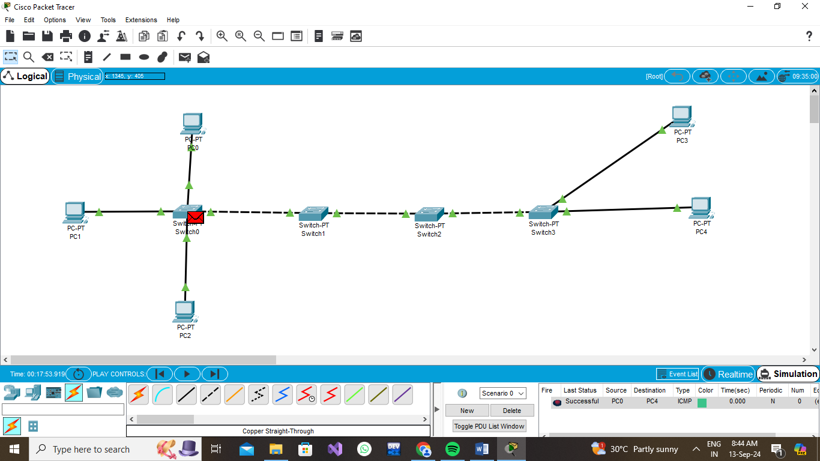

## CONCLUSION:

In conclusion, integrating tree and bus topologies into a hybrid network design offers a balanced approach to achieving energy efficiency while ensuring reliable communication. The tree topology's hierarchical structure supports scalable and organized data management, while the bus topology's simplicity facilitates straightforward and efficient communication paths. This combination leverages the strengths of both topologies, addressing their individual limitations and optimizing network performance.

The selection of energy-efficient communication protocols tailored for this integrated topology enhances overall system efficiency, reducing power consumption without compromising reliability. Through rigorous simulation and practical experimentation, the performance of this hybrid network can be evaluated to ensure that it meets the desired objectives in terms of scalability, fault tolerance, and efficiency.